*Florida International University*

*School of Computing and Information Sciences*

CIS 4911 - Senior Capstone Project

Software Engineering Focus

**Feasibility Study Report**

**Team Members:**

Vladan Lalovic

Daniel Lopez

Michael Martinez

Johnathan Jensen

**Product Owner(s)**:

Mohsen Tahari

**Mentor(s)**:

Mohsen Tahari

**Instructor**: Masoud Sadjadi

**Introduction:**

In this report we will assess the practicality of the proposed plan to integrate various features of Google Drive into the VIP 3.0 website using the Google Drive API. Our goals are to use the API to perform tasks such as:

**1)** Creating folders automatically

**2)** Adding/creating files automatically

**3)** Inserting names and information to the files automatically

**4)** Sharing access to the files and folders automatically.

**Feasibility Results:**

**1) Creating folders automatically**

**Feasible:** Yes

**Description:** This is definitely feasib**l**e, as we have already integrated this feature into VIP 3.0 (screenshots below), and it’s working. For reference, we used this Google API link - <https://developers.google.com/drive/v3/web/folder>. We referred to the following tutorial when creating the ‘Create Folder’ function - <https://bytutorial.com/tutorials/google-api/introduction-to-google-drive-api-using-javascript>.

**ScreenShot(s):**

1. **In this 1st image, I specify a new folder name to be created via the API.**

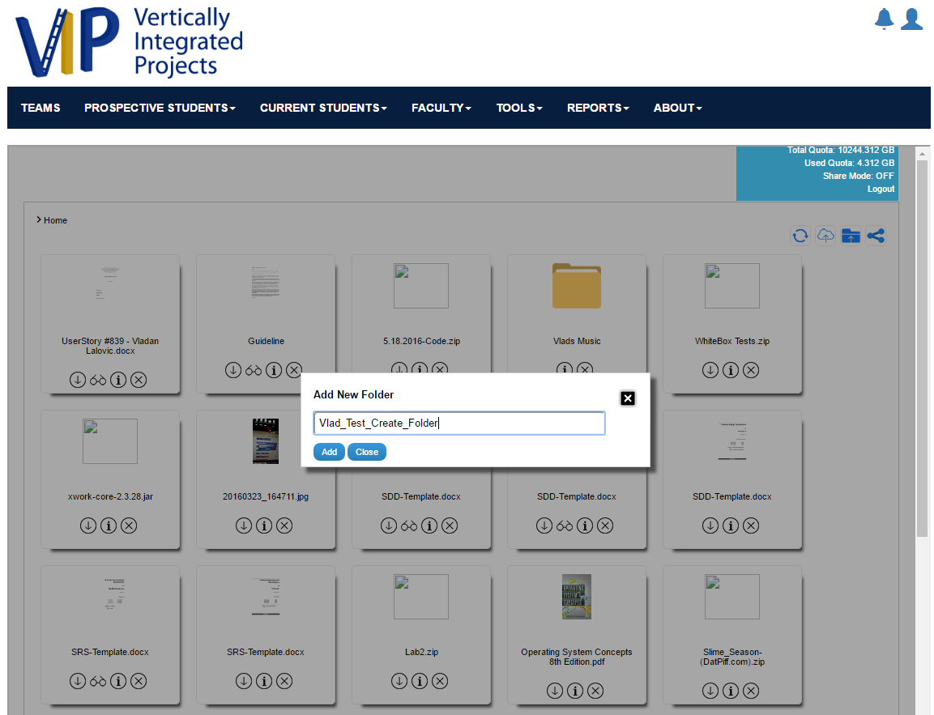

**B) In this 2nd image, we see the folder has been created**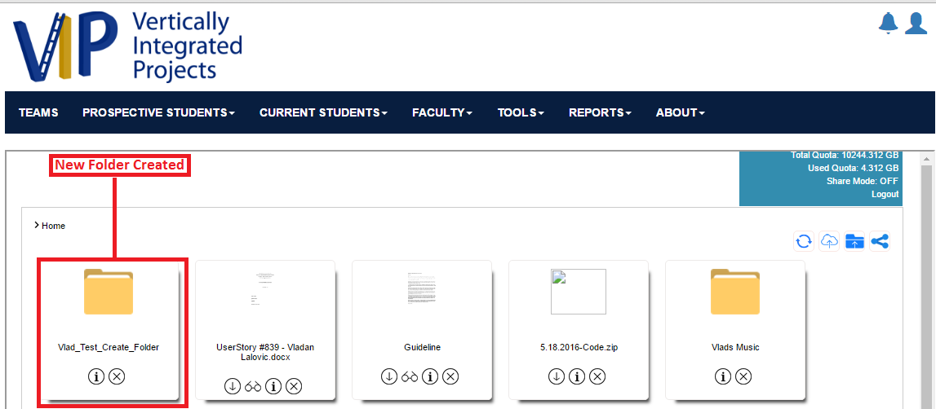

**2) Adding/creating files automatically**

**Feasible:** Yes, we believe so, but not 100% sure **(Read the Description below)**

**Description:** Currently, we know it’s feasible to upload **EXISTING** files from the hard drive to any Google Drive folder using the API. We have created a demo that proves to us that this is feasible. However, we are uncertain if it’s possible to create new, empty files on the Google Drive, but we are fairly confident that it is. We referred to the following tutorial when creating the ‘Upload/Add File’ function - <https://bytutorial.com/tutorials/google-api/introduction-to-google-drive-api-using-javascript>.

**ScreenShot(s):**

1. **In this 1st image, I specify a file - “Report.docx” - to upload into my new folder “Vlad_Test_Create_Folder”**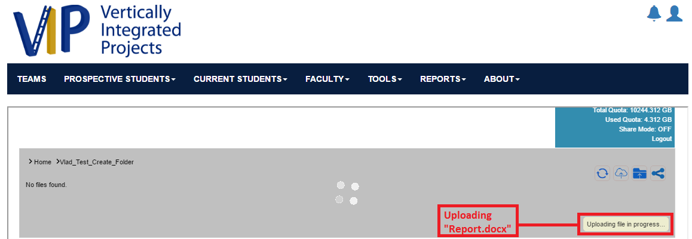
2. **In this 2nd image, we see that the file has been created, and added to the appropriate folder successfully.**

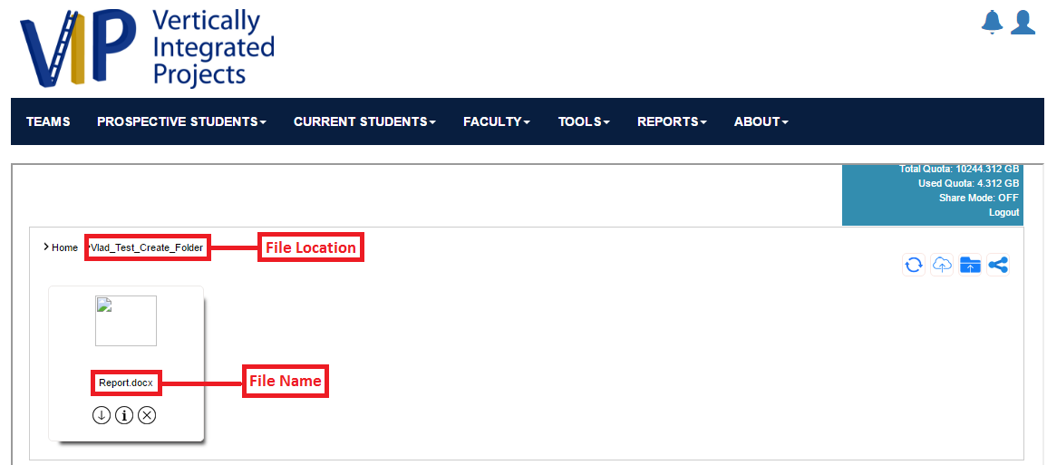

**3) Inserting names and information to the files automatically**

**Feasible:** We need clarification on exactly what “inserting names to the files automatically” means. However, “Updating the contents of a file” is definitely feasible, meaning, we can replace/change the contents of a file whenever we want via the API.

**Description:** According to this Google Drive API reference page, there is an ‘update’ function for modifying the contents of existing files on Google Drive - <https://developers.google.com/drive/v2/reference/files/update>.

**ScreenShot(s): N/A**

**4) Sharing access to the files and folders automatically.**

**Feasible:** Yes

**Description:** Although we have not created a demo which shares access to files and folders to a list of users, we know that it’s feasible due to the following reference in Google’s API - <https://developers.google.com/drive/v3/web/manage-sharing>. The line “Google Drive apps can manage permissions and sharing settings of files.” tells us that it’s feasible to have this feature.

**ScreenShot(s): N/A**